**Sense Autonomous**

**STEM**

**Science, Technology, Engineering, Mathematics**

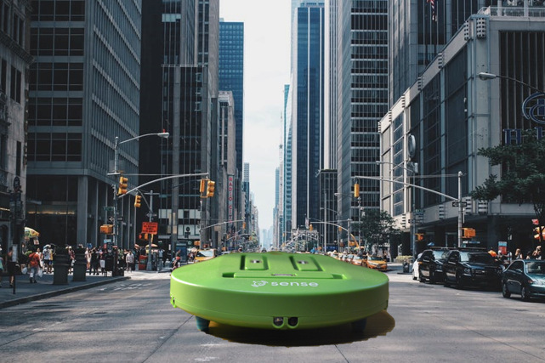

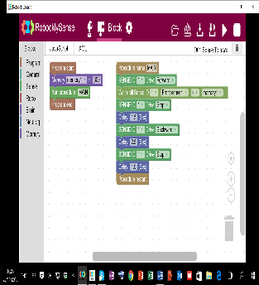

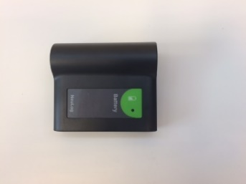**Sense Autonomous** is a mobile robot with flash memory, 5 range sensors on its perimeter and black line sensor for algorithm methods (especially in autonomous vehicles), innovation and coding with visual block program **RobocklySense**.

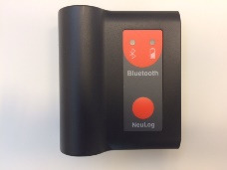By adding rechargeable battery (**BAT-202**), the robot becomes an autonomous robot moving according to a program in its flash memory.

By adding a Bluetooth module (**BLT-200**), which is also rechargeable battery, the robot becomes an autonomous robot programmed remotely by IPad, tablet or smartphone.

The Sense Autonomous leads to basic coding and algorithm methods acquirement, to challenge with autonomous vehicle exercises and innovation with expansion units and sensors.

The system suits everyone and comes with many example program, such as:

**Along walls**

**Along a black line**

**Between two lines**

**To a wall**

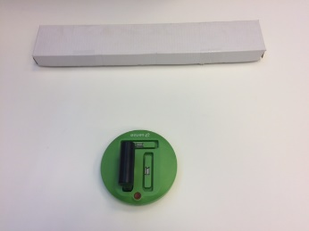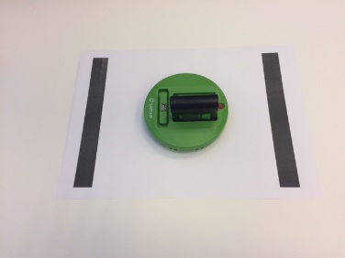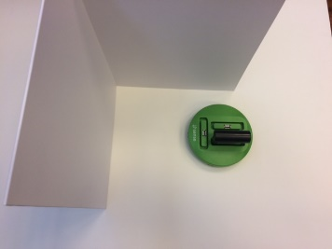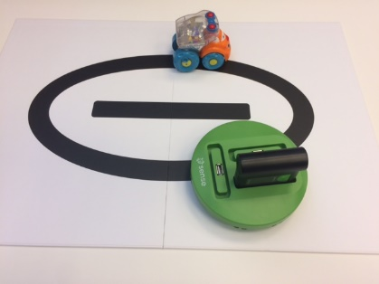

**Autonomous taxi**

**Autonomous car**

**AGV**

**Autonomous guard**

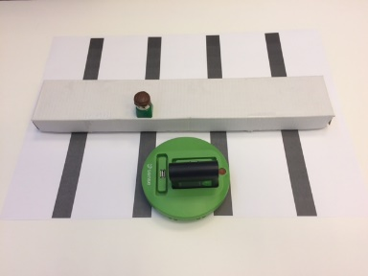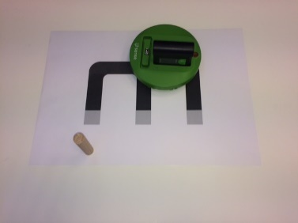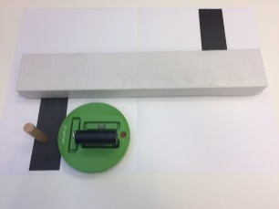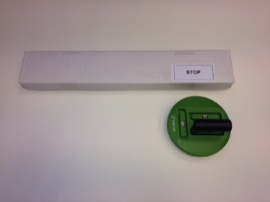

The **Sense Autonomous** has sockets for adds-on modules such as: Neulog sensors, Tracking Infrared (IR) transmitter, Gripper arm module, Coding units for programming in **Blockly, Python, C language** and **Arduino C.**

Example programs with adds-on modules:

**Sound sensor**

**Gripper arm**

**Distance sensor**

**Tracking IR transmitter**

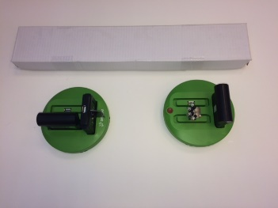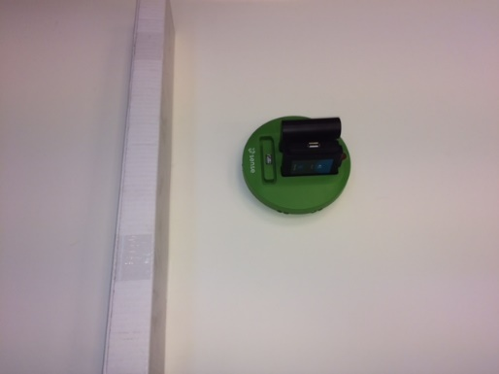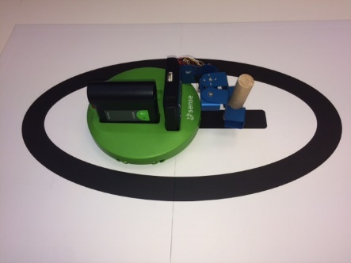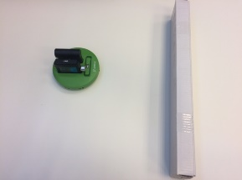

**Neulog**

Logger sensors

Over 50 various sensor plugged to each other.

The robot can react to sensor values and collects data automatically.

**SNS-101 + SNS-160**

Tracking module and IR Transmitter

Tracking unit that identifies IR light and its direction, which enables the robot to follow the IR transmitter.

The transmitter transmits Infrared light.

**SNS-167**

Gripper arm module

Gripper arm unit with servomotors that received commands from the robot:

Up – Mid – Down

Open - Close

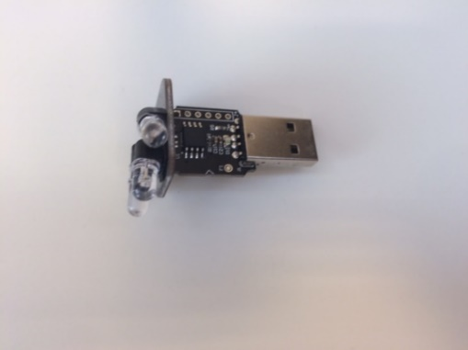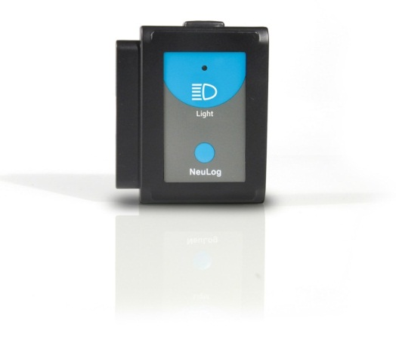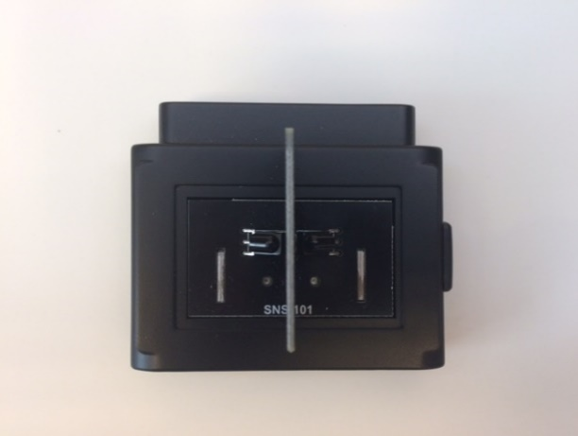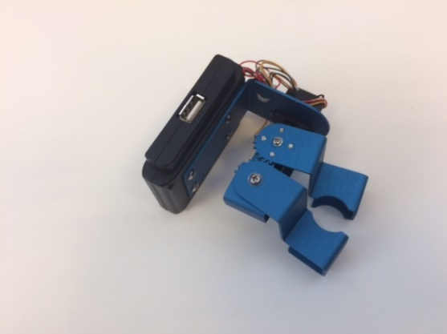

The Sense coding units enable to acquire the most popular programming languages in the industry and to write complex programs.

**WIFI-203**

**Wireless coding unit**

**CARM-202**

**C language coding unit**

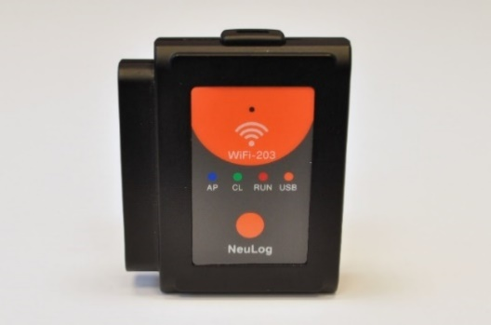

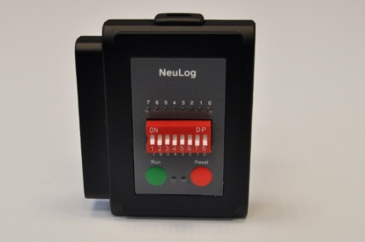

**C language**

**C** is a coding language for creating machine programs.

The module is used also as a trainer for C language – the most needed coding language in the industry.

**Python**

The **Python** is most popular programming language that works on any computer platform.

It is excellent for programs with many functions and procedures.

**Robockly**

**Robockly** has all **Blockly** (**Google** program) instructions, enhanced by SENSE instructions.

It has rich instruction sets such as loops, logic, mathematics, functions, arrays, text and variables.

